Time Management
Vicki Baugus
Respond instead of reacting.
Time Management - managing your time to get the important things done
1 hour of planning will save you 10 hours of doing.
If you always do what you've always done, you'll always get what you've always got.
Being successful doesn't make you manage your time well. Managing your time well makes you successful.

4 Areas of Time management
Prioritization
Managing Interruptions
Procrastination
Scheduling
Goal Setting

Prioritization
- Use a to do list
- 2 Steps in creating a to-do list
list everything out
if you have a larger task, break it into smaller pieces
maybe have several lists for different areas
go down the list and rank in order of importance

Urgent/Important Matrix
"Important Activities "Critical Activities"
"Distractions" "Interruptions"

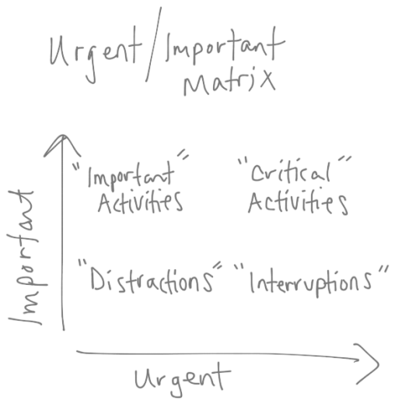

Most people do the upper right quadrant first.
"You're lack of planning is not my emergency."

Do the worst task first and the rest will seem easier.
Remember the Milk.com

Task list on Outlook
Touch e-mail one time. Touch a paper only once.

Your inbox IS NOT YOUR TO DO LIST

Managing Interruptions
It breaks your focus.
Learn to put your phone and e-mail to work for you.
Learn how to catch your breath. When you are interrupted you feel rushed.
Ask lots of questions and assess the situation.

Schedule yourself - you don't find time for important things, you make time for important things.

"Net Generation Leader" - Andy Stanley
Opportunity costs. Make sure you are managing your time well.
Schedule your day so that you accomplish your tasks..
Craig Grochelle - from Life Church
Protect your time and protect your time off.
Minimize interruptions of others. Get a folder or list for your one or one time with your supervisor.
Anticipate questions that they will ask you. Think through some possible answers.

Procrastination
It is as tempting as it is deadly
First step - recognize you have an issue with procrastination
Reasons for procrastination - unorganization
- hard time distinguishing between the important and urgent
- distraction
- forgetfulness
- lumping (not seeing steps and breaking it down)

Scheduling
Effective scheduling system

5 Step Process
1. Identify the time you have available
2. Block an essential task that you have to do a good job.
3. Review your to-do and schedule in your high priorities activities
4. Block in contingency time for interruptions
5. Block in Discretionary time

Goal Setting
Goal setting is the process of deciding what you want.
Why should we set goals?
it puts you in the driver seat
you will lack focus and direction
it gives you a benchmark
goal setting helps you prioritize
setting goals give you clarity
Typical goal setting
- at the beginning of the year
- "Losing Weight" is too vague, not a goal

You need to write down your goals.

2 Ingredients that CCV will tell the staff
1. A written goal focus' on the result (the what, not the activity which is the how)

5 Golden Rules of Goal Setting
1 - set goals that motivate you, write down why it is important to you
2 - set smart goals (SMART, it all stand for something)
Specific
Measurable
Attainable
Relevant
Time bound (set a timeframe for the goal)
3 - write down the goal - physical act of writing it down makes it real and tangible
4 - make an action plan
5 - be diligent, stick with it, hold yourself accountable and set reminders

