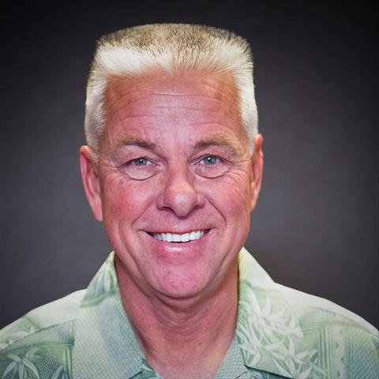
Mike McClain - Neighborhood Pastor
Christ’s Church of the Valley - Phoenix, AZ
2/05/2014

TCM International
Small campus - from his observations, most of the young people who go on staff don't stay too long. They eventually move on to something else.
Beautiful countryside and history.
Teams that visit are assigned students to pray for.
Demographics of the student body are varied.
- Armenia, Belarus, Bulgaria, Czech Republic, Georgia, Georgia-Russia, Germany, Moldova, Poland, Romania, Russia, Turkmenistan
2016 Plan - growing Branch Locations and Teaching & Research Locations

Margin is toughest for Mike. Working as a contractor and fireman, there is always a finish/complete line. You hang your hat, shut the light off and leave. Contracting you have to submit your final paperwork before getting paid. Ministry never ends - there is always more to do and there is no "off". You have to decide when to be "off".
Habits he already had in place: hiking in the morning with ear buds/scripture.

Referenced book:
The One Thing - Gary W. Keller

