Peoria Campus – 14 sites

- Walmart Neighborhood Market
6550 West Happy Valley Road
Glendale, AZ 85310
(623) 566-9754

- Fry's Food
6625 W Happy Valley R, Glendale, AZ 85310-2617
(623) 561-8905

- Safeway ‎
3800 West Happy Valley Road
Phoenix, AZ 85310
(623) 518-1946‎

- Walmart Supercenter
2501 West Happy Valley Road #34
Phoenix, AZ 85085
Happy Valley Towne Center
(623) 780-5702
- TopLine Foods ‎
2222 West Parkside Lane
Phoenix, AZ 85027
(623) 444-7749

- Target
2727 West Agua Fria Freeway
Phoenix, AZ 85027
Deer Valley Towne Center‎
(623) 869-8070

- Walmart Neighborhood Market
4230 West Union Hills Drive
Glendale, AZ 85308
(623) 869-0779

- Fry's Food Store Pharmacy
20220 North 59th Avenue
Glendale, AZ 85308
(623) 825-3111

- Safeway
20205 North 67th Avenue
Glendale, AZ 85308
(623) 572-8814

- Albertsons
20255 North 59th Avenue
Gbafaf, Arizona 85308
(623) 572-7186

- Albertsons Market
8240 W Deer Valley Rd
Peoria, AZ 85382
(623) 572-5744

- Fry's Food
8375 West Deer Valley Road
Peoria, AZ 85382
(623) 561-5504

- Walmart Supercenter
21655 North Lake Pleasant Parkway
Peoria, AZ 85382
(623) 537-0809

- Super Target
24890 North Lake Pleasant Parkway
Peoria, AZ 85383
(623) 376-7300

Peoria

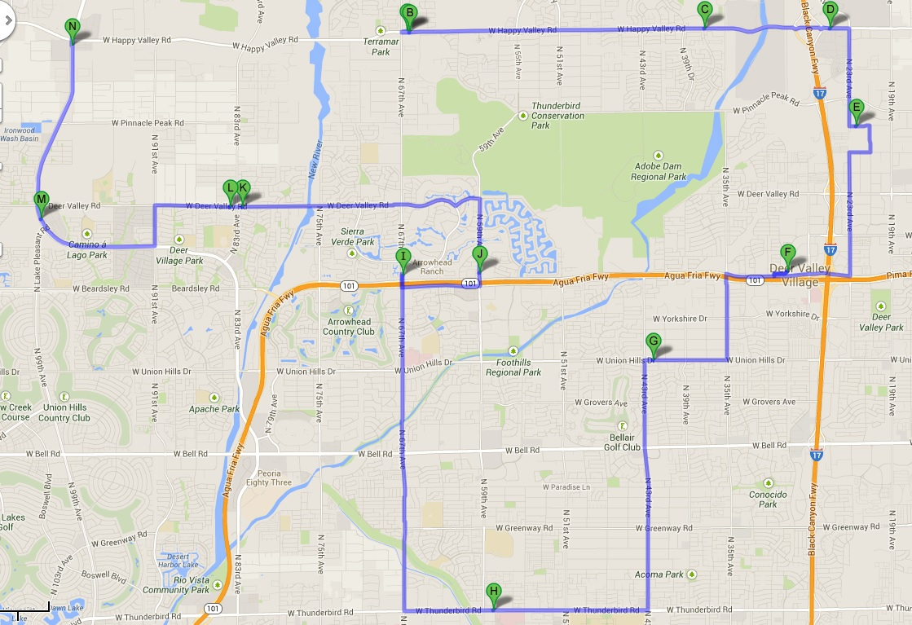
Surprise Campus – 7 sites
Ken Fechner
Neighborhood Pastor
KenFechner@ccvonline.com
(623) 376-2444
- Walmart Supercenter
12900 W Thunderbird Rd, El Mirage, Arizona ‎ 2.9 mi NE
(623) 583-1321
Dave VanDonge
Surprise Campus Pastor
DaveVanDonge@ccvonline.com

- Safeway
13828 W Waddell Rd, Surprise, AZ ‎ 1.9 mi NE
(623) 476-1810
Dave VanDonge
Surprise Campus Pastor
DaveVanDonge@ccvonline.com

- Fry's
13982 W Waddell Rd, Surprise, AZ ‎ 1.9 mi NE
(623) 537-9630 ‎

- Bashas'
15367 W Waddell Rd, Surprise, AZ ‎ 1.6 mi NW
(623) 214-6460 ‎

- Walmart* added via Kati Cekosh
14111 N Prasada Gateway Ave.
623-282-32098
Kati Cekosh
KatieCekosh@ccvonline.com
(623) 875-9000 ext. 2820

- Fry's* added via Kati Cekosh
15215 N Cotton Ln.
623-455-7900

- Sprouts Farmers Market
13759 W Bell Rd, Surprise, AZ ‎ 3.7 mi N
(623) 544-3121

Surprise
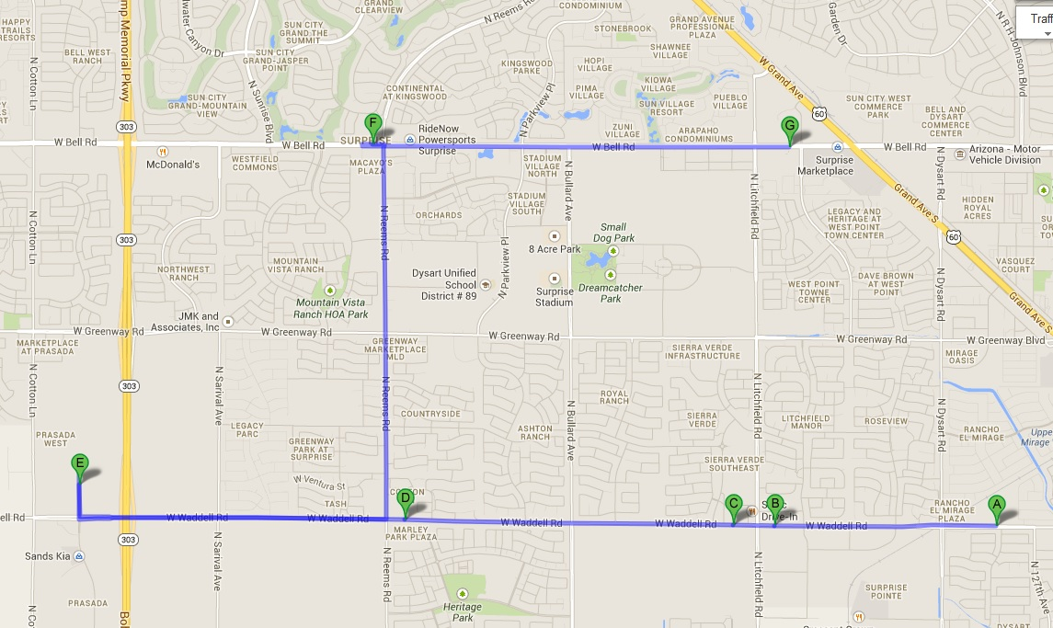
Scottsdale Campus – 9 sites
- Walmart *added by Travis Brown
34399 N Cave Creek Rd, Cave Creek, AZ
(480) 296 7398
(Our contact over there is the store manager named Matt Mower. If you need to contact him, I have already spoken to him about being a part of anything that we are doing. He is completely on board.)

- Albertson’s *added via MacKenzie
21001 N Tatum Blvd #76
Phoenix, AZ 85050

- AJ’s *added via MacKenzie
23251 N Pima Rd
Scottsdale, AZ

- Fry’s
20427 N Hayden Rd, Scottsdale, AZ ‎ 1.3 mi NW
(480) 419-2240

- Costco Scottsdale
15255 N Hayden Rd, Scottsdale, AZ ‎ 2.4 mi S
(480) 948-5040

- Target
15444 N Frank Lloyd Wright Blvd,
Scottsdale Towne Center
(480) 860-2800

- Bashas'
MacKenzie Lee
MacKenzieLee@ccvonline.com
(480) 502-9800
Ross Richardson
Neighborhood Pastor
RossRichardson@ccvonlin.com
623) 376-2444
Travis Brown
Scottsdale Campus Pastor
TravisBrown@ccvonline.com
10111 E Bell Rd, Scottsdale, AZ ‎ 1.9 mi SE
McDowell Mountain Marketplace
(480) 513-7560

- Safeway
14696 N Frank Lloyd Wright Blvd, Scottsdale, AZ ‎ 2.7 mi S
Scottsdale Horizon Shopping Plaza
(480) 391-1090

- Albertsons Market
15660 N Frank Lloyd Wright Blvd, Scottsdale, AZ ‎ 2.0 mi S
Scottsdale Towne Center
(480) 451-9825 ‎

Scottdale
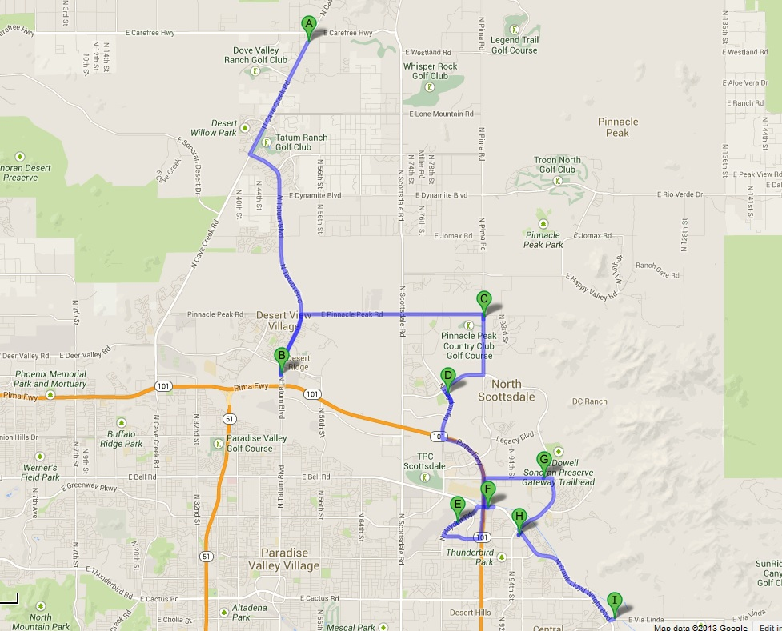

East Valley Campus – 8 sites

- Safeway
Kevin Carlson
East Valley Campus Pastor
KevinCarlson@ccvonline.com
9101 E Baseline Rd, Mesa, AZ ‎ 1.5 mi SW
Monte Vista Village Center Shops
(480) 281-0161

- Walmart Neighborhood Market
8335 E Guadalupe Rd, Mesa, AZ ‎ 2.8 mi SW
(480) 357-4137 ‎

- Albertsons Market
9243 E Baseline Rd, Mesa, AZ ‎ 1.3 mi SW
The Shoppes at Augusta Ranch
(480) 986-3060

- Bashas' Supermarket
9925 E Baseline Rd, Mesa, AZ ‎ 0.9 mi S
Eric Surrett
Neighborhood Pastor
EricSurrett@ccvonline.com
(623) 376-2444
(480) 354-2798
‎
- Fresh & Easy Neighborhood Market
2758 S Crismon Rd, Mesa, AZ ‎ 1.8 mi S
(480) 357-2120 ‎

- Walmart Supercenter *added via Kevin (says it’s probably the biggest supplier in area)
1606 S Signal Butte Rd Mesa, AZ 85209
(480) 358-1122

- Bashas' Supermarket *added via Kevin
Signal Butte & Apache Trail
10715 E. Apache Trail
Apache Junction, AZ 85120

- Fry’s *added via Kevin
435 S Ellsworth Rd Mesa, AZ 85208
(480) 380-1005
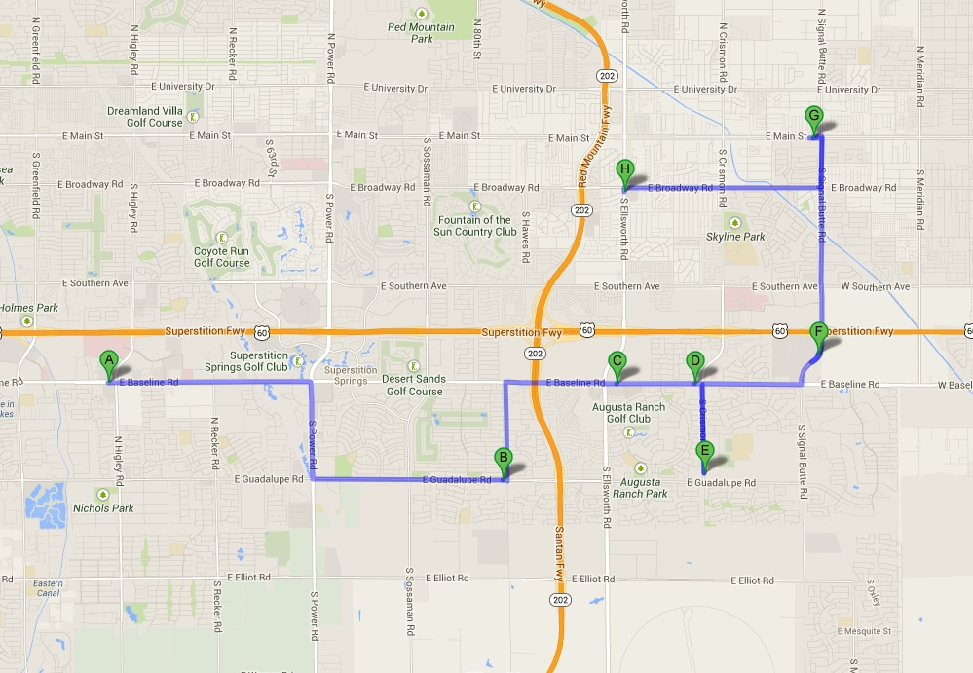
East Valley

